Investigation Procedures

- Make sure you have recorded the material your group is testing above the data table on Deformation Results. Adjust your push-pull spring scale so it reads “0” N when no force is applied to it.
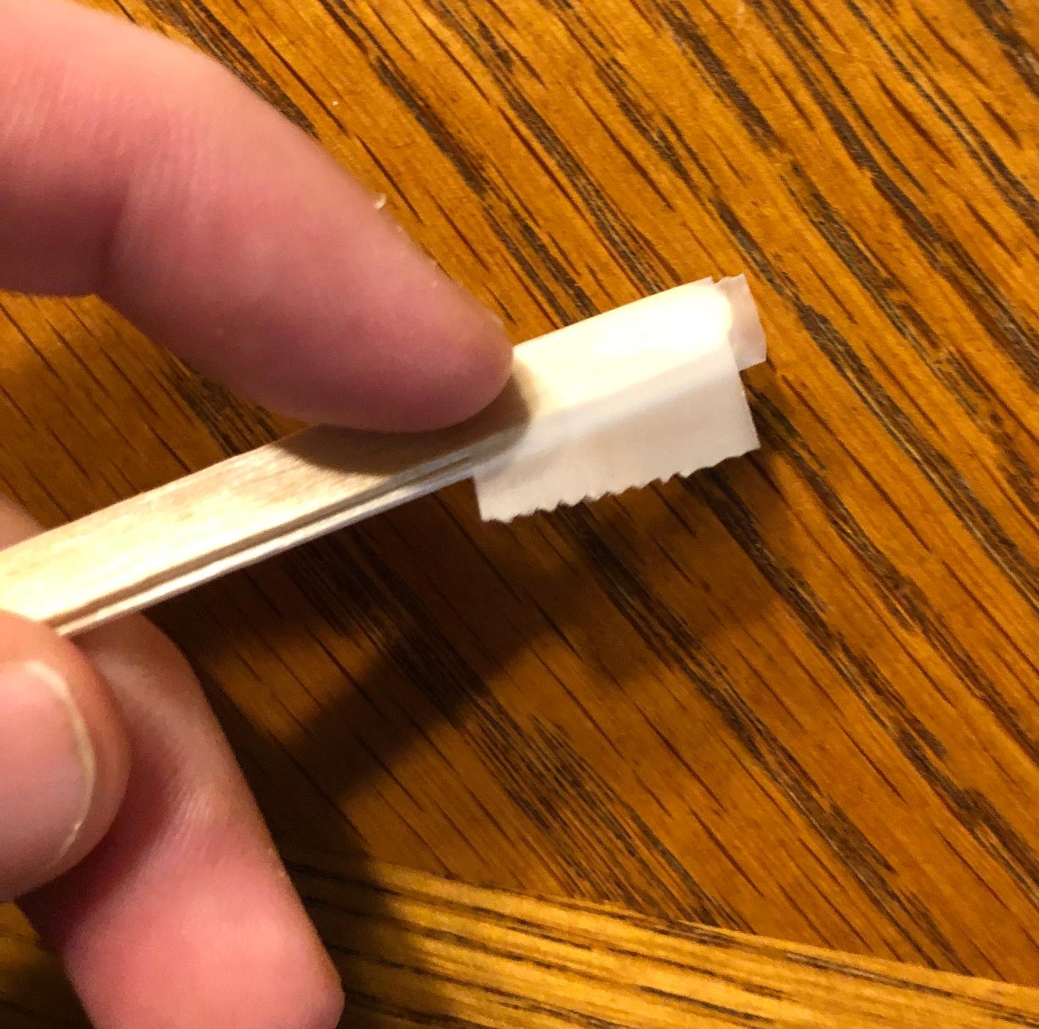
- If you are testing two layers, tape the edges of your two layers together. Use a pencil to mark the center point of your object where you will apply a force using the spring scale.
- Place your material between two bricks with the amount of each end of the material overlapping the brick that the class agreed on. Tape down one end of the material to the brick surface.
- Measure in centimeters the height of the center point of your object above the table. Record this in column B of row 1 and in row 2 of the data table on the Deformation Results handout.
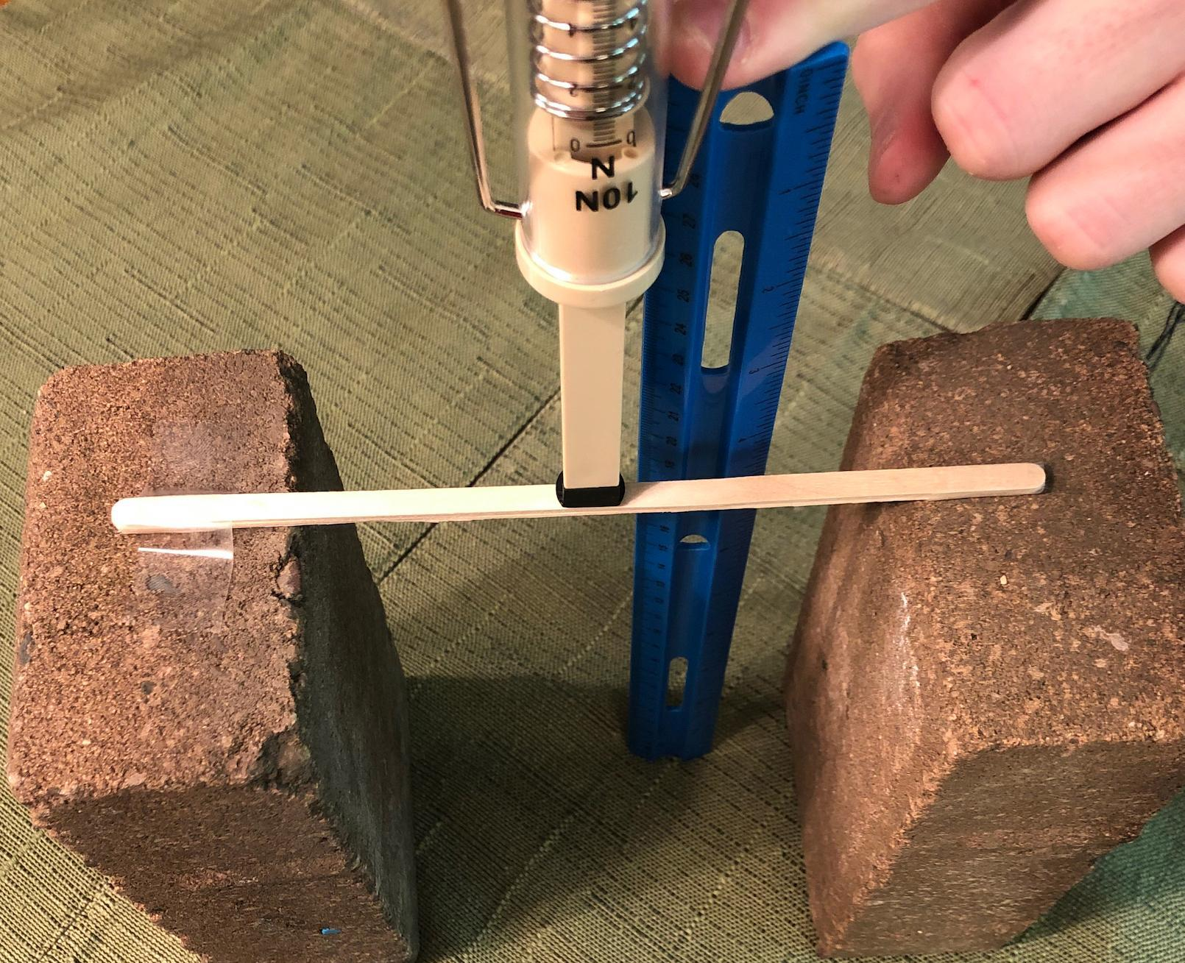
- One member of the group should place a spring scale against the center point of the object and push down with 1 N force and hold it at that level. Another group member should measure in centimeters the height of the beam with the force applied to it. Have a third member record that height in row 2, column C and calculate the deformation in column D of the data table. In column A of row 2, write the force used, in this case “1.”
- Remove the force from the object. Record in column F whether the object returns to its original shape when the force was removed.
- Repeat the last two steps for additional data points. Use different amounts of force than ones you already tested. However, reserve at least 2 measurements to repeat a previously tested amount. Remember to record the height before you apply the force in column B and the amount of force you apply in column A.
- When you have the table complete, have other members of the group make a copy of the data in their own data tables.
- Don’t graph your data until instructed by your teacher.

